**E-Healthcare_BSMRSTU**

A Project Report submitted to the

Department of Computer Science and Engineering,

Bangabandhu Sheikh Mujibur Rahman Science and Technology University

in partial fulfillment of the requirements for the degree of

B.Sc. in Computer Science and Engineering

By

Md. Juwel Mallick

ID: 18CSE018

Session: 2018 - 2019

Supervised by

Dr. Mrinal Kanti Baowly

Associate Professor



DEPARTMENT OF COMPUTER SCIENCE AND ENGINEERING

BANGABANDHU SHEIKH MUJIBUR RAHMAN SCIENCE AND TECHNOLOGY UNIVERSITY

MAY 2022

Abstract

The main purpose of this project is to provide e-health services and information to the BSMRSTU community. People are getting confused by various misinformation. Using this project, it is very easy to get various information about our service and the user can get various advice about what to do at this time with his information. By following these instructions, they will be able to stay safe at this time. There are various mass awareness instructions. Which in turn can reduce the health hamper. There is a lot of information about our members. Using it, the public can contact the corona control department and receive various services.

**Project Approval**

Student’s Name: Md. Juwel Mallick

Student’s ID: 18CSE018

Project Title: E-Healthcare_BSMRSTU

We the undersigned, recommend that the project be completed by the student listed above, in partial fulfillment of B.Sc. Engineering degree requirements, be accepted by the Department of Computer Science and Engineering, Bangabandhu Sheikh Mujibur Rahman Science and Technology for deposit.

**Supervisor Approval\***

**………………………………..**

Dr. Mrinal Kanti Baowly

Associate Professor

Department of Computer Science and Engineering

**Bangabandhu Sheikh Mujibur Rahman Science and Technology University, Gopalganj, Bangladesh**

Acknowledgement

I would like to express my sincere gratitude to my supervisor Dr. Mrinal Kanti Baowly for providing their invaluable guidance, comments, and suggestions throughout the

The course of the project.

I perceive this as a good opportunity for my career development.

I am very grateful to the great creator for completing the project.

Md. Juwel Mallick

18CSE018

May,2022

# **Table of contents**

**Abstract ii**

**Project approval iii**

**Acknowledgement iv**

**List of Figures vii**

1. **Introduction**
   1. Introduction …………………………………………………………………….….1
   2. Motivation & Aims……...…………………………………………..………….….2
   3. Objectives ……………….…………………………………………………..……..2
   4. Scope of the Project ………………………………...…………………….….…….3
   5. Modules………………………….………………..……………………….……….3
2. **REQUIREMENT SPECIFICATION**
   1. Introduction………………………….……………………………..……………….4
   2. Hardware requirements…….…………………………………………....………….4
   3. Software requirements…….…………………………………………………….….5
   4. Software specification…………………………………………….……………..….5
   5. Connectivity…….…………………………………………………………...…..….6
   6. Localization…….…………………………………………………..……………….8
   7. User and tools…….…………………………………………………………..….….9
   8. Why to use mysql…….………………………………………………..………...….9
   9. Xml…….……………………………………………………………………...…….9
   10. J2me…………………………………………………………………………….......10
3. **Procedure**
   1. Some screenshots of running project…………………………...……………….…11
4. **Limitations on and future plan**
   1. Limitation………………………………………………………………….…....…14
   2. ure plan……………………………………………………………….…..…….….14
5. **Conclusion**
   1. Conclusion…………………………………………………………………..……..15

# **Reference**…………………………………………………………..…………..…16

# **List of Figures**

1.1: E-healthcare 1

1.2: Project ensure good health3

1.3: Login window 4

2.1: Database logo 7

3.1: Welcome window 11

3.2: Login window 12

3.3: Admin window 12

3.4: Display window 13

**CHAPTER 1**

**Introduction**

* 1. **Introduction**

Healthcareis a field in which accurate record-keeping and communication are critical and yet in which the use of computing and networking technology lags behind other fields. Healthcare professionals and patients are often uncomfortable with computers and feel that computers are not central to their healthcare mission, even though they agree that accurate record-keeping and communication are essential to good healthcare. In current healthcare, information is conveyed from one healthcare professional to another through paper notes or personal communication.

 Fig. 1.1 E-healthcare

For example, in the United States, electronic communication between physicians and pharmacists is not typically employed, rather, the physician writes a prescription on paper and gives it to the patient. The patient carries the prescription to the pharmacy, waits in line to give it to a pharmacist, and waits for the pharmacist to fill the prescription. To improve this process, the prescriptions could be communicated electronically from the physician to the pharmacist, and the human-computer interfaces for the physicians, nurses, pharmacists, and other healthcare professionals could be voice-enabled.

* 1. **Motivation & Aims**

Effective and timely communication between patients, physicians, nurses, pharmacists, and other healthcare professionals is vital to good healthcare. Current communication mechanisms, based largely on paper records and prescriptions, are old-fashioned, inefficient, and unreliable. When multiple healthcare professionals and facilities are involved in providing healthcare for a patient, the healthcare services provided aren’t often coordinated. Typically, a physician prescribes paper and gives it to the patient. The patient carries the prescription to the pharmacy, waits in line to hand the prescription to the pharmacist, and waits for the pharmacist to fill the prescription. The pharmacist might be unable to read the physician’s handwriting; the patient could modify or forge the prescription, or the physician might be unaware of medications prescribed by other physicians. These and other problems indicate the need to improve the quality of healthcare. This paper describes a distributed e-healthcare system that uses the Service-Oriented Architecture as a means of designing, implementing, and managing healthcare services.

This paper describes a distributed e-healthcare system that uses the Service- Oriented Architecture as a means of designing, implementing, and managing healthcare services

* 1. **Objectives**

1. Define E-healthcare
2. Recording information about the Patients that come.
3. Recording information related to the diagnosis given to Patients.
4. Keeping a record of the Immunization provided to children/patients.
5. Keeping information about various diseases and medicines available to cure them.

These are the various jobs that need to be done in a Hospital by the operational staff and Doctors. All these works are done on paper.

**1.4 Scope of the Project:-**

1. Information about Patients is done by just writing the Patients name, age, and gender. Whenever the Patient comes up his information is stored freshly.
2. Bills are generated by recording the price for each facility provided to the Patient on a separate sheet and at last they all are summed up.
3. Diagnosis information to patients is generally recorded on the document, which contains Patient information. It is destroyed after some time to decrease the paper load in the office.
4. Immunization records of children are maintained in pre-formatted sheets, which are kept in a file
5. Information about various diseases is not kept as any document. Doctors themselves do this job by remembering various medicines.

 Fig. 1.2 Project ensure good health

All this work is done manually by the receptionist and other operational staff and a lot of papers are needed to be handled and taken care of. Doctors have to remember various medicines available for diagnosis and sometimes miss better alternatives as they can’t remember them at that time.

**1.5 MODULES:**

The entire project mainly consists of 5 modules, which are

* Admin module
* Teacher module
* Doctor module
* Nurse module
* Student module

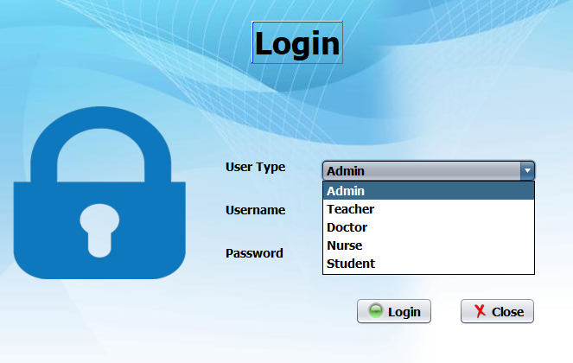

Fig. 1.3 Login window

**CHAPTER 2**

**REQUIREMENT SPECIFICATION**

**2.1 INTRODUCTION:**

To be used efficiently, all computer software needs certain hardware components or other software resources to be present on a computer. These prerequisites are known as(computer) system requirements and are often used as a guideline instead of an absolute rule. Most software defines two sets of system requirements: minimum and recommended. With the increasing demand for higher processing power and resources in newer software versions, system requirements tend to increase over time. Industry analysts suggest that this trend plays a bigger part in driving upgrades to existing computer systems than technological advancements.

**2.2 HARDWARE REQUIREMENTS:**

The most common set of requirements defined by any operating system or software application is the physical computer resources, also known as hardware. A hardware requirements list is often accompanied by a hardware compatibility list (HCL), especially in the case of operating systems. An HCL lists tested compatible, and sometimes incompatible hardware devices for a particular operating system or application. The following sub-sections discuss the various aspects of hardware requirements.

**HARDWARE REQUIREMENTS FOR THE PRESENT PROJECT**:

PROCESSOR: Intel dual Core,i3

RAM : 1 GB

HARD DI : 80 GB

**2.3 SOFTWARE REQUIREMENTS:**

* Windows Operating System 2000 and Above
* JDK 1.5
* Web Browser – Internet Explorer
* Apache Tomcat 5.5 Server
* Derby Database
* JSP and Servlets
* Axis Web Service
* Atom/RSS
* J2ME
* XML

Software Requirements define software resource requirements and pre-requisites that need to be installed on a computer to provide optimal functioning of an application. These requirements or prerequisites are generally not included in the software installation package and need to be installed separately before the software is installed.

**SOFTWARE REQUIREMENTS FOR THE PRESENT PROJECT:**

OPERATING SYSTEM: Windows 10/7/ XP/8

FRONT END: javascript.

SERVER SIDE SCRIPT: Php

DATABASE: Mysql

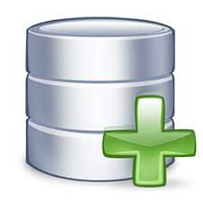

Fig. 2.1 Database logo

**2.4 SOFTWARE SPECIFICATION**

**MySQL:**

MySQL is developed, distributed, and supported by Oracle Corporation. MySQL is a database system used on the web it runs on a server. MySQL is ideal for both small and large applications. It is very fast, reliable, and easy to use. It supports standard SQL. MySQL can be compiled on several platforms.

The data in MySQL is stored in tables. A table is a collection of related data, and it consists of columns and rows. Databases are useful when storing information categorically.

**FEATURES OF MySQL:**

Internals and portability:

1. Written in C and C++.
2. Tested with a broad range of different compilers.
3. Works on many different platforms.
4. Tested with Purify (a commercial memory leakage detector) as well as with Val grind, a GPL tool.
5. Uses multi-layered server design with independent modules.

#### 

#### Security:

1. A privilege and password system that is very flexible and secure, and that enables host-based verification.
2. Password security by encryption of all password traffic when you connect to a server.

#### Scalability and Limits:

1. Support for large databases. We use MySQL Server with databases that contain 50 million records. We also know of users who use MySQL Server with 200,000 tables and about 5,000,000,000 rows.
2. Support for up to 64 indexes per table (32 before MySQL 4.1.2). Each index may consist of 1 to 16 columns or parts of columns. The maximum index width is 767 bytes for **InnoDB** tables or 1000 for **MyISAM**; before MySQL 4.1.2, the limit is 500 bytes. An index may use a prefix of a column for [**CHAR**](https://dev.mysql.com/doc/refman/5.0/en/char.html), [**VARCHAR**](https://dev.mysql.com/doc/refman/5.0/en/char.html), [**BLOB**](https://dev.mysql.com/doc/refman/5.0/en/blob.html), or [**TEXT**](https://dev.mysql.com/doc/refman/5.0/en/blob.html) column types.

#### 2.5 CONNECTIVITY:

Clients can connect to MySQL Server using several protocols:

* Clients can connect using TCP/IP sockets on any platform.
* On Windows systems in the NT family (NT, 2000, XP, 2003, or Vista), clients can connect using named pipes if the server is started with the [--enable-named-pipe](https://dev.mysql.com/doc/refman/5.0/en/server-options.html#option_mysqld_enable-named-pipe) option. In MySQL 4.1 and higher, Windows servers also support shared-memory connections if started with the [--shared-memory](https://dev.mysql.com/doc/refman/5.0/en/server-options.html#option_mysqld_shared-memory) option. Clients can connect through shared memory by using the --protocol=memory option.
* On UNIX systems, clients can connect using Unix domain socket files.

#### 2. 6 LOCALIZATION:

* The server can provide error messages to clients in many languages.
* All data is saved in the chosen character set.

**2.7 User AND TOOLS**:

* MySQL includes several client and utility programs. These include both command-line programs such as [**mysqldump**](https://dev.mysql.com/doc/refman/5.0/en/mysqldump.html) and **[mysqladmin](https://dev.mysql.com/doc/refman/5.0/en/mysqladmin.html" \o "4.5.2 mysqladmin — Client for Administering a MySQL Server)** and graphical programs such as [MySQL Workbench](http://dev.mysql.com/doc/refman/5.1/en/workbench.html).
* MySQL Server has built-in support for SQL statements to check, optimize, and repair tables. These statements are available from the command line through the **[mysqlcheck](https://dev.mysql.com/doc/refman/5.0/en/mysqlcheck.html" \o "4.5.3 mysqlcheck — A Table Maintenance Program)** client. MySQL also includes **[myisamchk](https://dev.mysql.com/doc/refman/5.0/en/myisamchk.html" \o "4.6.3 myisamchk — MyISAM Table-Maintenance Utility)**, a very fast command-line utility for performing these operations on **MyISAM** tables.
* MySQL programs can be invoked with the --help or -? Option to obtain online assistance.

**2.8 WHY TO USE MySQL:**

* Leading open-source RDBMS
* Ease of use – No frills
* Fast
* Robust
* Security
* Multiple OS support
* Free
* Technical support
* Support large database– up to 50 million rows, file size limit up to 8 Million TB

**2.9 XML:**

Java Platform, Micro Edition (Java ME) provides a robust, flexible environment for applications running on mobile and other embedded devices—mobile phones, personal digital assistants (PDAs), TV set-top boxes, and printers. Java ME includes flexible user interfaces, robust security, built-in network protocols, and support for networked and offline applications that can be downloaded dynamically. Applications based on Java ME are portable across many devices, yet leverage each device's native capabilities.

**2.10 J2ME:**

Java Platform, Micro Edition (Java ME) provides a robust, flexible environment for applications running on mobile and other embedded devices—mobile phones, personal digital assistants (PDAs), TV set-top boxes, and printers. Java ME includes flexible user interfaces, robust security, built-in network protocols, and support for networked and offline applications that can be downloaded dynamically. Applications based on Java ME are portable across many devices, yet leverage each device's native capabilities.

**Chapter 3**

**Procedure**

5.1 Some screenshots of my projects:

**Welcome page:**

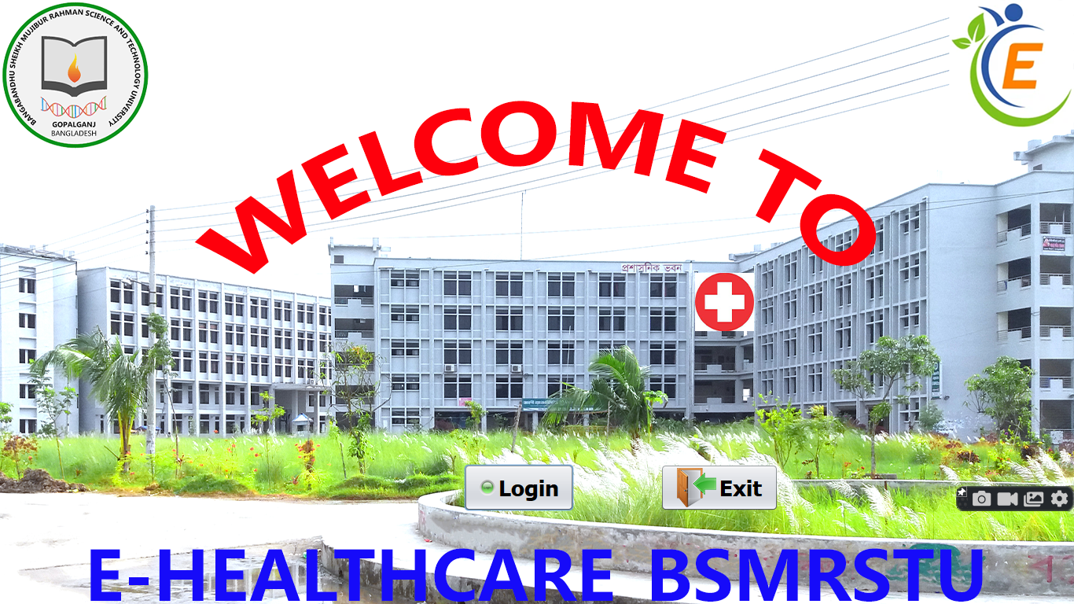 Fig. 3.1 Welcome window

**Login page**

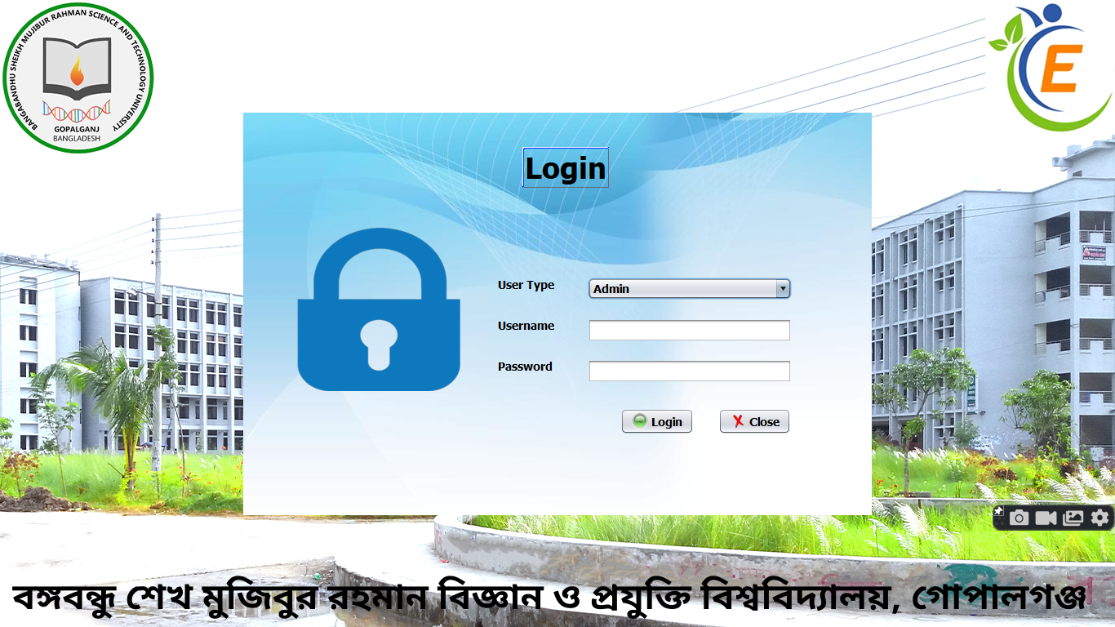

Fig. 3.2 Login window

**Admin panel:**

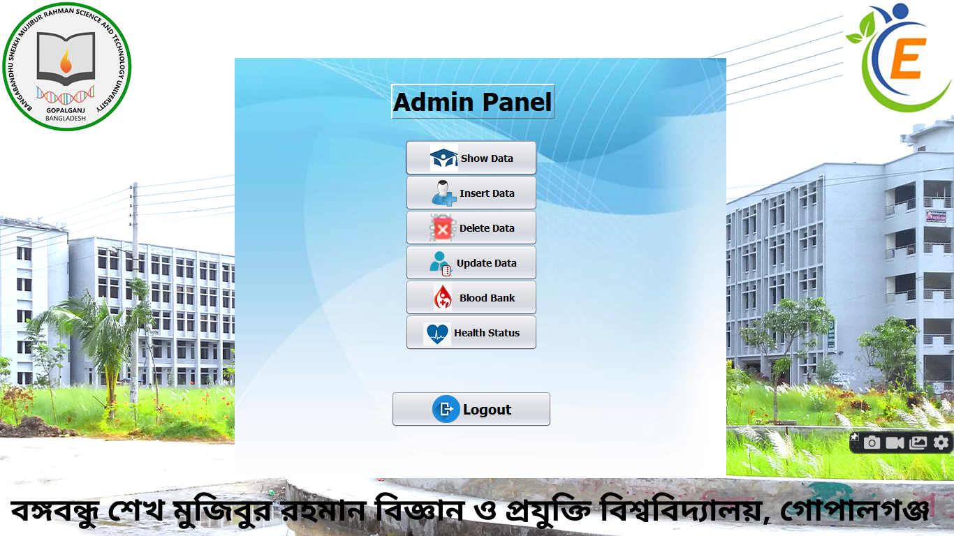 Fig. 3.3 Admin window

**Display window:**

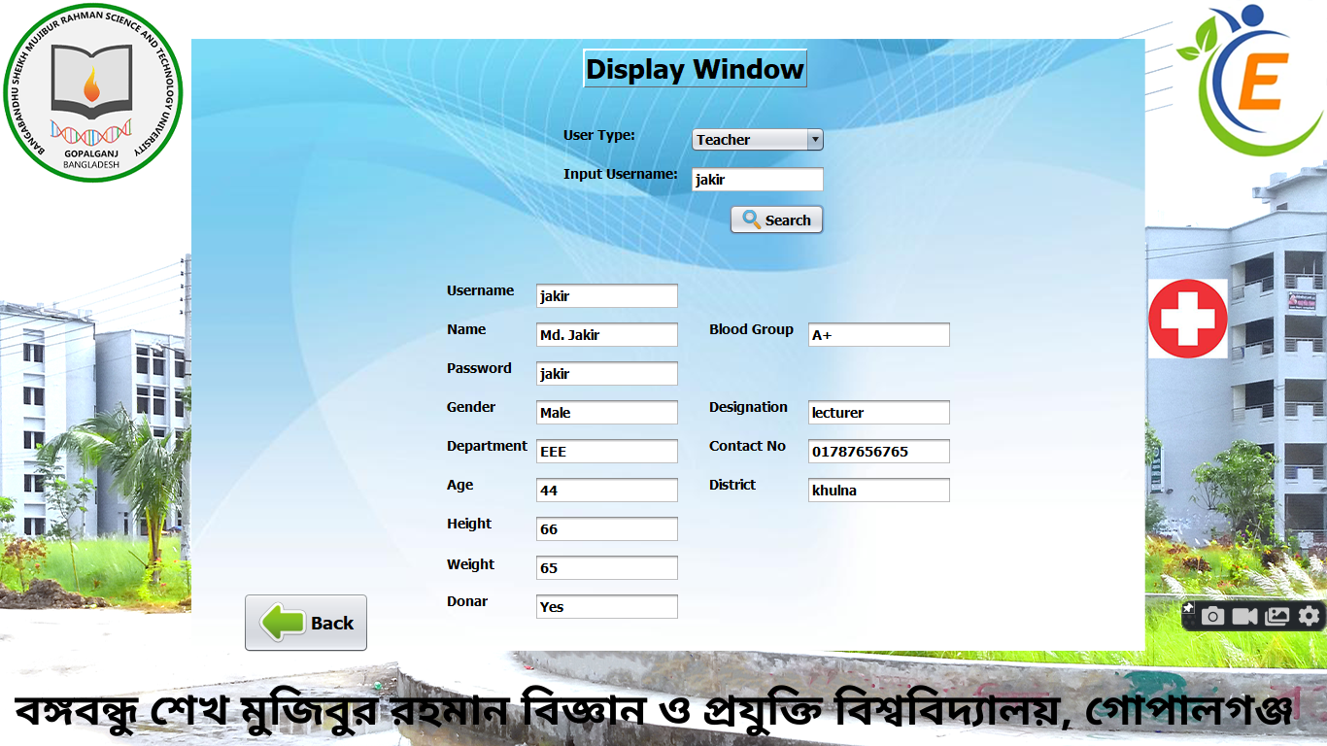 **Fig. 3.4 Display window**

**Chapter 4**

**Limitations and plan**

**4.1 Limitation**

* There is less information here.
* There are a few diseases.
* There is a small dataset.
* No direct connection between doctor and user
* No help center

**4.2 plan**

* I want to add more information with the proper dataset
* I want to add Graph & Chart for statistics
* I want to add monthly health status features.
* I want to develop a webpage for easy use.
* I want to add telemedicine features to the webpage.

**Conclusion**

**5.1**  Since we are entering details of the patients electronically in the” Hospital Management System”, data will be secured. Using this application we can retrieve a patient’s history with a single click. Thus processing information will be faster. It guarantees accurate maintenance of Patient details. It easily reduces the bookkeeping task and thus reduces the human effort and increases accuracy speed.

**Reference**

**Reference:**

[**https://www.wikipedia.org**](https://www.wikipedia.org)

[**https://www.who.int**](https://www.who.int)

[**https://www.cdc.gov**](https://www.cdc.gov)